**Project background**

About 12,500 arm amputations happen every year. The types of arm amputations vary, but hand and lower arm amputations are a common place occurrence. In order to help amputees, mechanical hands and arms were developed, and have existed for years. These arms are often operated by cables attached to the shoulder and control the hand by shrugging the shoulder. Unfortunately these devices make inaccurate motions, do not grasp irregularly shaped objects well, uncomfortable, and expensive. Other types of prosthetic hands are controlled by myoelectric hands have existed for the last 5-10 years. These prosthetics are very expensive and heavy.

This project is designed to overcome limitations from these commercially available prosthetics. This project is designed to be 3-D printed to lower both cost and weight. Additionally, the device will be made available for public use as open source, so anyone with a 3-D printer can print out his own device.

**Problem Statement**

The solution to the above issues is to create an open-source, affordable, and high functioning prosthetic hand. This hand should be task-oriented and able to achieve everyday household activities that require low strength and high dexterity such as opening doors and picking up various objects. The major issues involved in creating this mechanical hand are maintaining dexterity of the fingers, maintaining device durability, and holding low costs.

**Conceptual design**

The second main category of designs to consider is the granular jamming pads. This category is split up into material of the granular material, the housing of the pads, and the layout and control of pads.

The first component to consider is what granular material to use in the pads. Materials the group considered are sand, coffee grounds, and plastic stuffing materials. All three materials are inexpensive, but each has a drawback. Sand is heavy, coffee grounds will spoil, and plastic stuffing materials are too large for finger tips. The team needs to do more investigation into what material to use.

|  |  |  |  |  |
| --- | --- | --- | --- | --- |
| Category: | Simplicity | Affordability | Feasibility | Totals: |
| Category Weight: | 10 | 8 | 9 |  |
| Item: |  |  |  |  |
| Balloon | 8 | 10 | 7 | 223 |
| Silicone | 9 | 9 | 8 | 234 |

The next component to consider is the housing material. Materials to consider are balloons and silicone. Balloons are inexpensive, but are not durable or easy to cut into irregular shapes. Silicone is more expensive, but more durable and can be cast into any shape desired.

The final component to consider is the layout of the pads. The pads could either be interconnected or all attached to the vacuum. Additionally the number of pads is a design to consider. Pads could either be on only the fingertip, the tip and the base, or the tip, base, and midsection of the fingers. Increasing the number of pads per fingers increases the ability to grasp, but also increases the complexity of the hand.

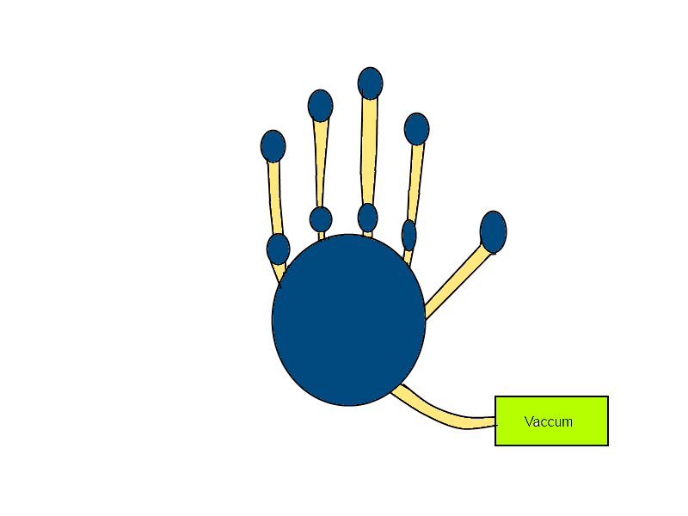The group decided to do some preliminary testing in order to design a layout for the pads. This was done by covering household objects with chalk, using the object with a hand, and observing where the chalk stuck to the hand. At the time of presentation, the group was planning on using a configuration similar to that of FIGURE, where blue areas are pads of the device, and yellow areas are connection medium.

It was suggested to the group to lessen the amount of pads in order to simplify control of the pads. The group will be looking into lowering the number of pads. Areas to investigate are the number of points of contact needed to hold an object and how much force is needed to hold an object in a hand.